**NAME: Chinmay Kulkarni**

**USN: 22BTRCL089**

**BRANCH/SEC: AIML/C**

**SQL ASSINGMENT**

1. **Task – 1: DDL**
   1. Creating a new table called "Customers" and “Employees” with the following columns:
      1. CustomerID (integer, primary key)
      2. FirstName (string, maximum 50 characters)
      3. LastName (string, maximum 50 characters)
      4. Email (string, maximum 100 characters)
      5. Phone (string, maximum 20 characters)
      6. Address (string, maximum 100 characters)

"Employees" Table: Create a new table called "Employees" with the following columns (to be modified later):

EmployeeID (integer, primary key)

FirstName (string, maximum 50 characters)

LastName (string, maximum 50 characters)

Age (integer)

Salary (integer)

**CODE:**

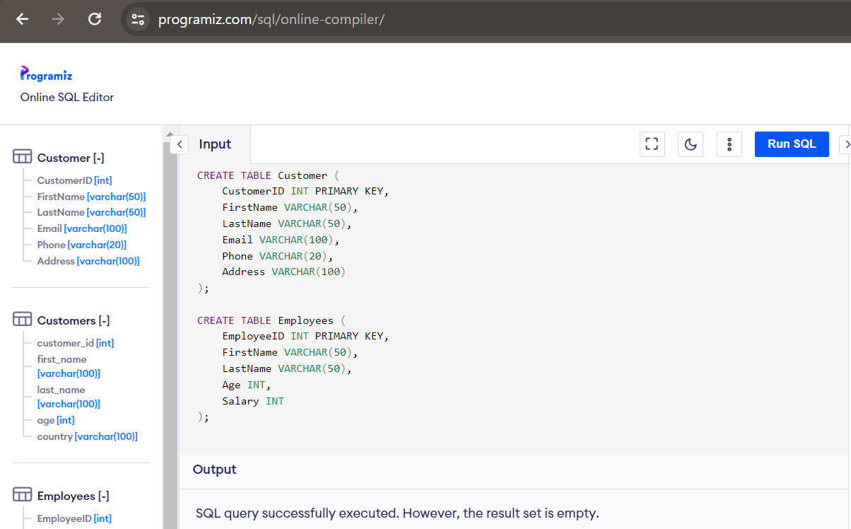

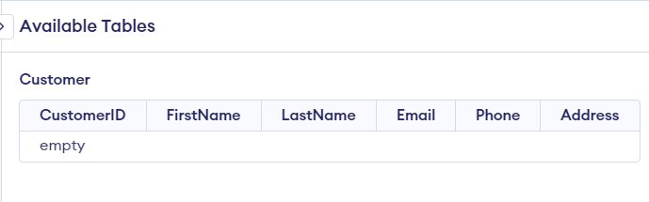

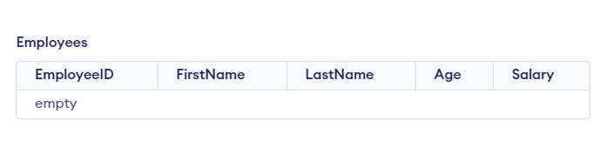

* 1. Modifying the "Employees" table to add a new column called "Email" with a maximum length of 100 characters. This column should allow NULL values.

**CODE:**

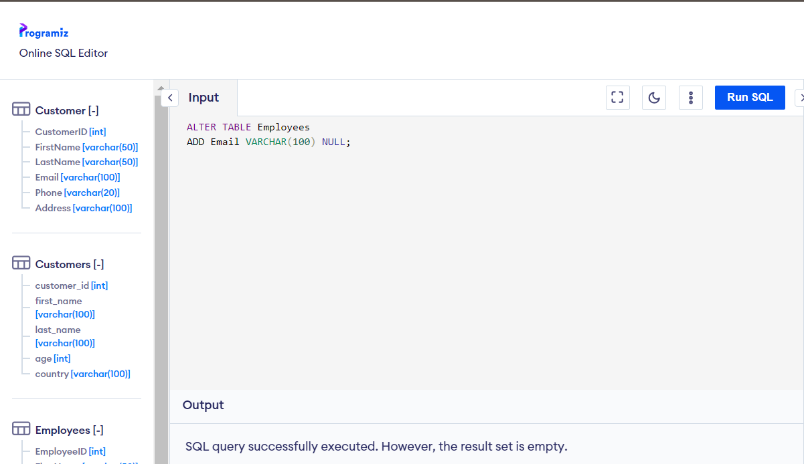

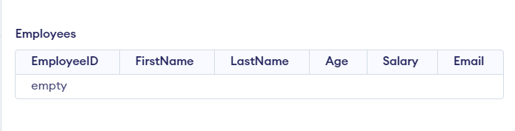

* 1. Altering the "Employees" table to change the data type of the "Age" column to VARCHAR(3).

**CODE:**

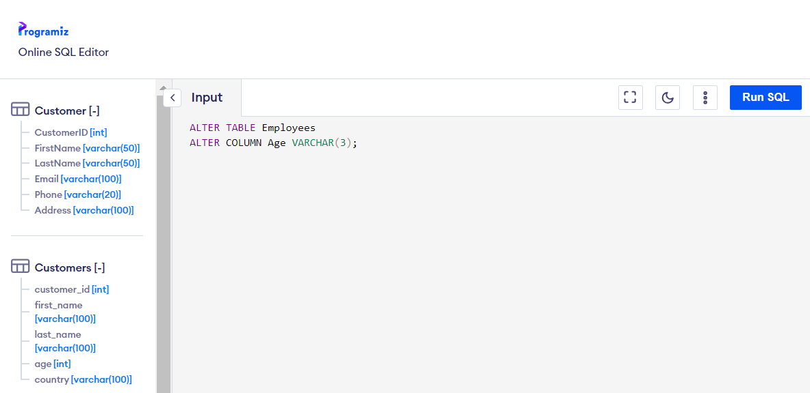

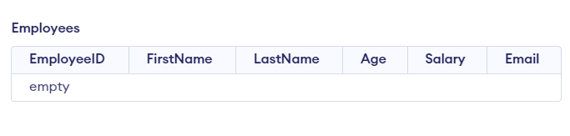

* 1. Adding a constraint to the "Salary" column in the "Employees" table to ensure that the salary value is greater than or equal to 0.

**CODE:**

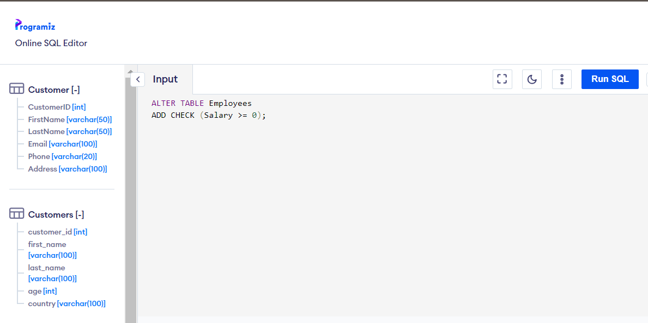

* 1. Dropping the "Customers" table from the database.

**CODE:**

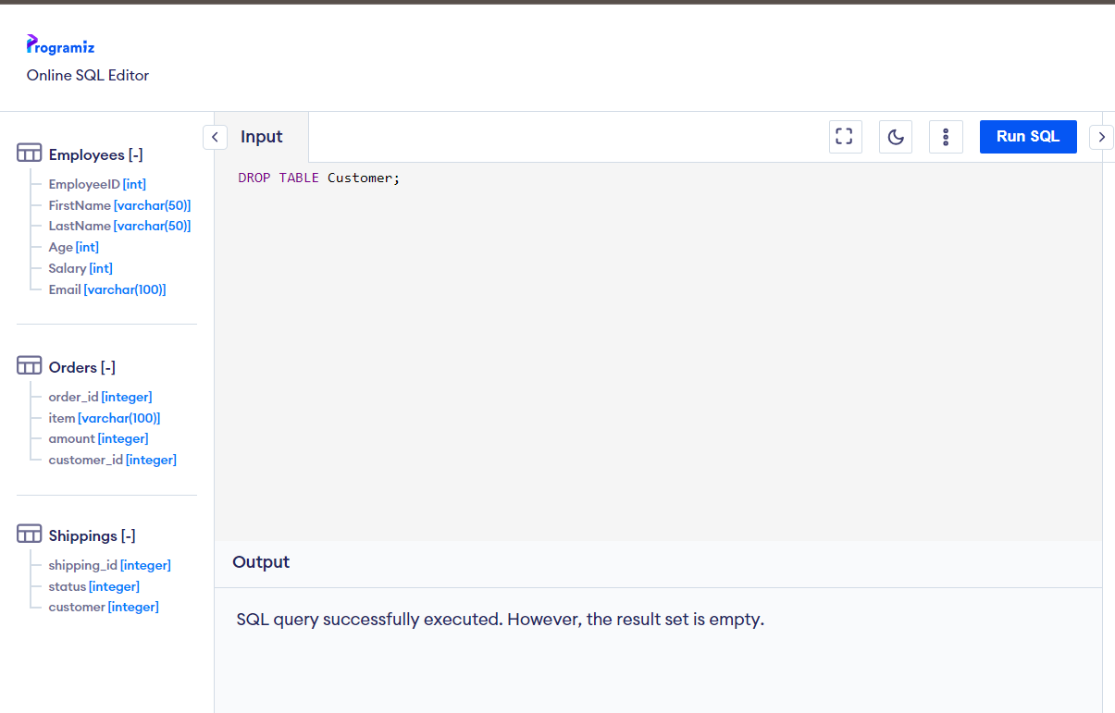

1. **Task – 2 : DML**

You have been tasked with managing the customer data in a database table called Customers. The table has the following structure:

TABLE Customers

CustomerID

FirstName

LastName

Email

Phone

Address

Initially, the Customers table contains the following data:

CustomerID | FirstName | LastName | Email | Phone | Address

-----------------------------------------------------------------------------------------

101 | John | Doe | johndoe@example.com | 123-456-7890 | 123 Main Street

102 | Jane | Smith | janesmith@example.com | 987-654-3210 | 456 Elm Avenue

103 | Robert | Johnson | robertjohnson@example.com | 555-123-4567 | 789 Oak Drive

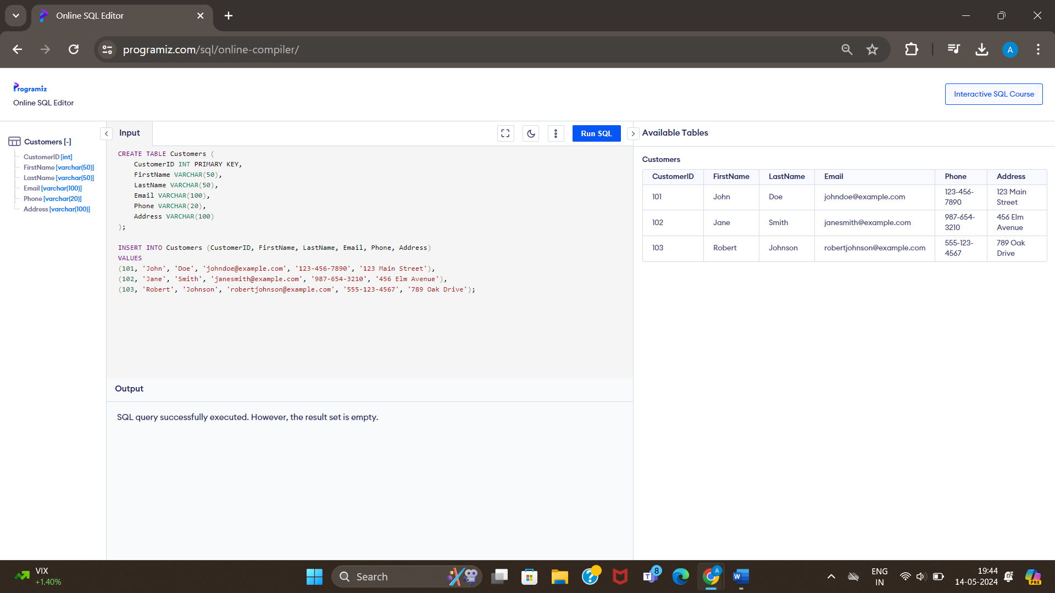

Perform the following data manipulation operations on the Customers table using SQL statements. Write SQL queries to accomplish the following tasks:

* 1. Inserting a new customer: Write an SQL query to insert a new customer with the following details:

CustomerID: 104

FirstName: 'Sarah'

LastName: 'Williams'

Email: 'sarahwilliams@example.com'

Phone: '111-222-3333'

Address: '789 Maple Street'

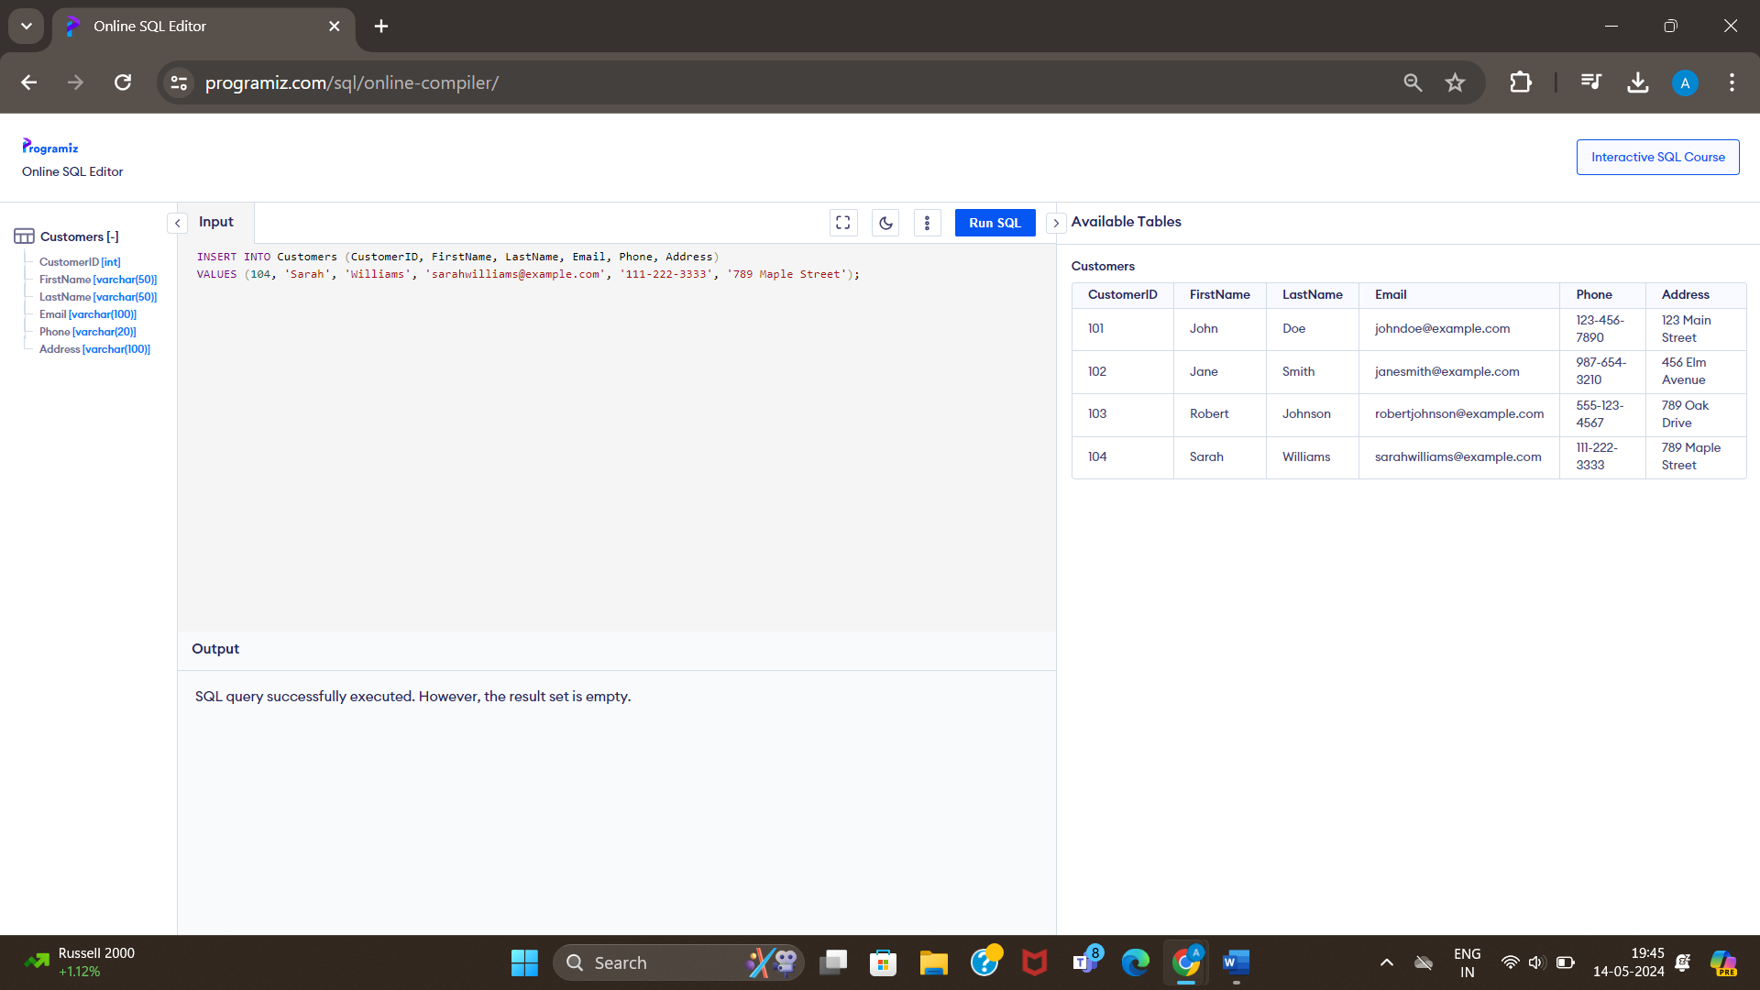

* 1. Updating customer information: Write an SQL query to update the phone number of the customer with CustomerID 101 to '987-654-3210'.

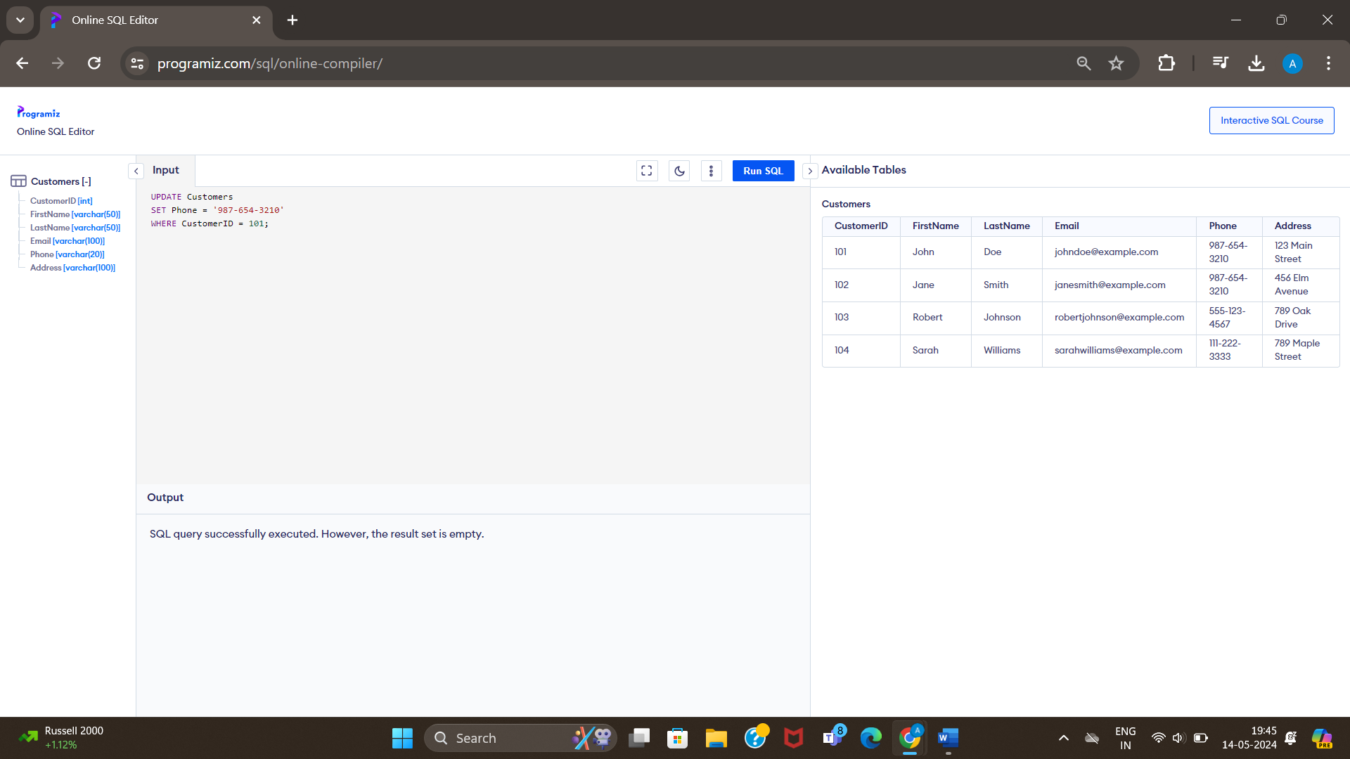

* 1. Deleting a customer: Write an SQL query to delete the customer with CustomerID 103 from the Customers table.

